Alan Ray
CS 3435-101
Dr. R. Perry
12/3/2025

Final Project Report

Abstract
My project uses Selenium to scrape the games on OpenCritic, cleans the data, displays some relevant data and graphs, and uses a linear regression model to predict the top critic average based on some input features.
It uses Selenium’s WebDriver to scrape across thousands of dynamically loaded pages. The default configuration collects 10,000 game entries in a single run, but this takes several hours. The README.txt includes instructions for altering the program to use pre-scraped data or scrape a smaller number of games.
The program checks OpenCritics robots.txt rules using the Protego library and only proceeds if automated access is allowed. Selenium then navigates through the first 500 pages (by default) of the list at opencritic.com/browse/all. From each of these pages it visits each of the 20 linked item pages. Some attributes are scraped from the index pages, while others are scraped from the item pages. On each page it waits for required elements to load and waits half a second just to be polite. Results are stored as a JSON Lines file.
After scraping or loading pre-scraped data, the project cleans the data. This includes removing or converting missing values, standardizing numeric fields, converting strings to lists where necessary, and dropping the small portion of scraped items that don’t have enough critic reviews to have a top critic average.
The cleaned data is passed into an exploratory analysis function that generates textual summaries and graphs. The graphs visualize relationships and trends among the data: how are the scores distributed? Which creators are most prolific? Which genres are critically beloved? Which year saw the most releases? And so on.
The final component uses a linear regression model to predict the top critic average from selected input features.

Data
The data is scraped from 10,000+ pages (by default) starting at opencritic.com/browse/all. The program iterates through 500 index pages, and from each of those index pages, visits 20 item pages. By page 500, the program has collected every game with a valid top critic average (a score other than -1).
Ten attributes are scraped for each game. On the index pages each game’s rank, url, genre(s), and release date are scraped. On the item pages each game’s name, top critic average, critics recommend percentage, creator(s), platform(s), and number of reviews are scraped.
Games with 0 critic reviews or an invalid top critic average (less than 0) are dropped during the cleaning phase. This is only necessary if more than 9,000 games are scraped. Games with less than 20 reviews are dropped during the modeling phase, as these have no critic recommendation percentage – something we want to use as an input feature.

Visualization
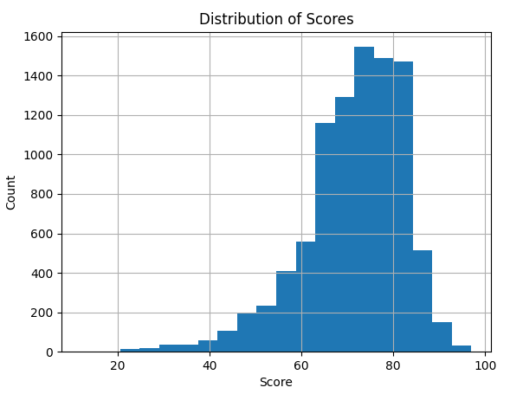
The game with the highest top critic average is Super Mario Odyssey with a 97. The game with the lowest top critic average is The Day Before with a 12. The average score is 71.28.
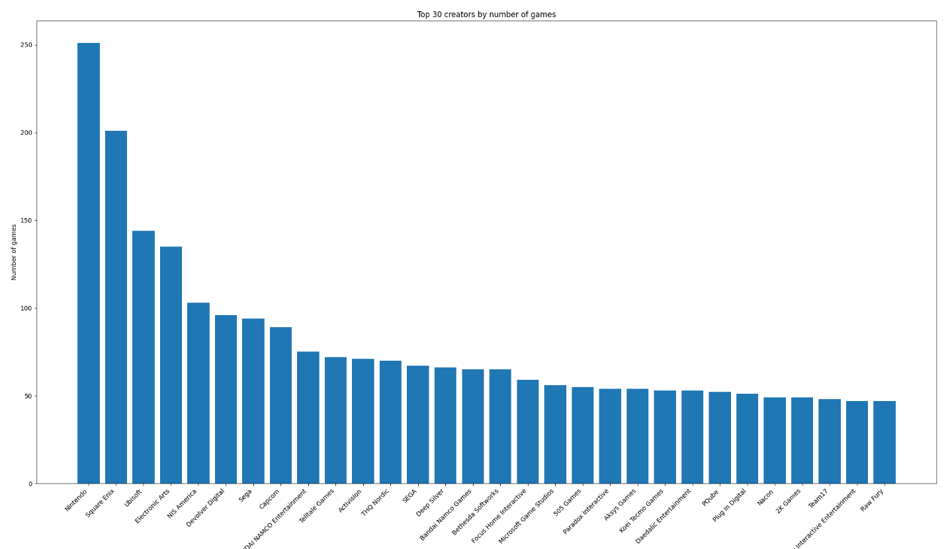
Out of 5,855 creators, Nintendo is the most prolific. Square Enix, Ubisoft, and Electronic Arts also have a lot of games in the dataset.
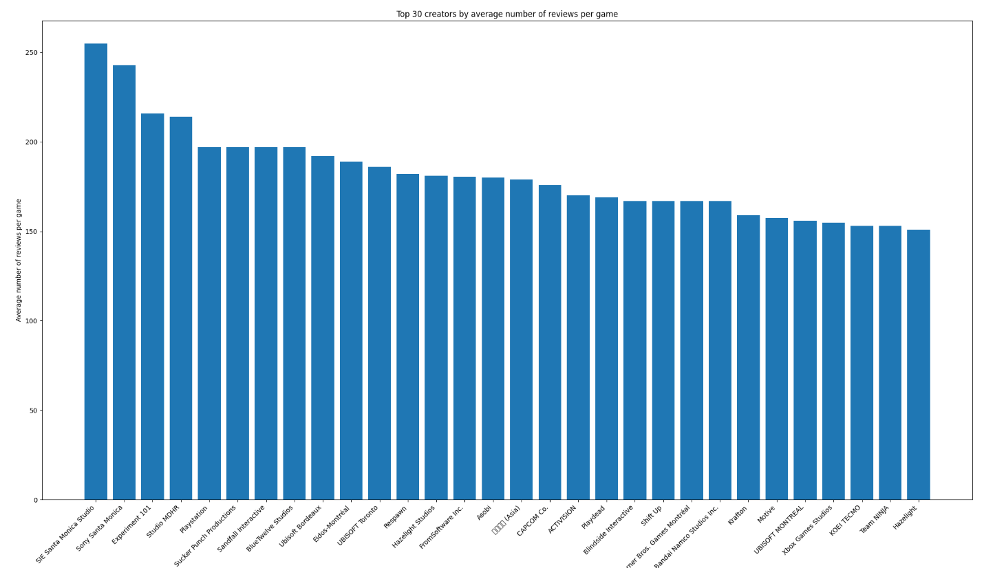
This data is less useful, as many of these studios have only one or two games in the dataset. Nonetheless, it points to some studios that draw a lot of critical attention.

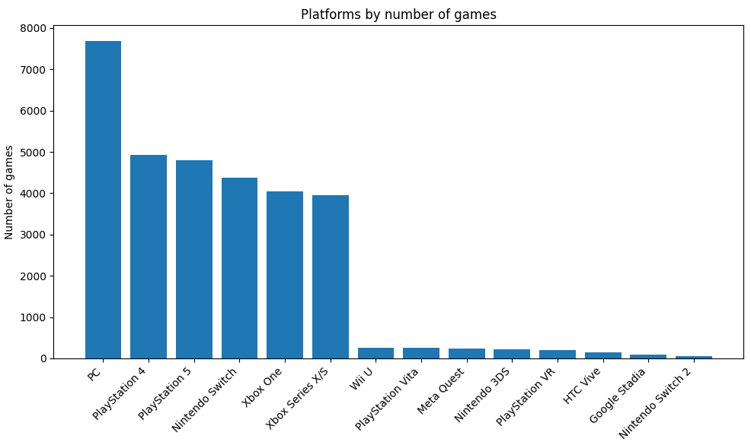
Most of the games scraped had a PC release. About half were released on PS4, PS5, Nintendo Switch, Xbox One, or Xbox Series X/S. The other 8 platforms in the dataset had relatively few releases.
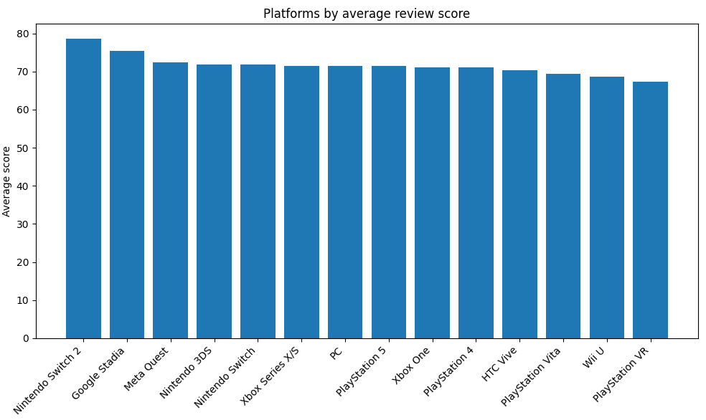
The platforms that had the fewest games released for them were outliers with regards to the average review score. Nintendo consoles, Stadia, and Meta Quest had higher than average review scores. Playstation VR, Wii U, and Playstation Vita had lower than average scores.

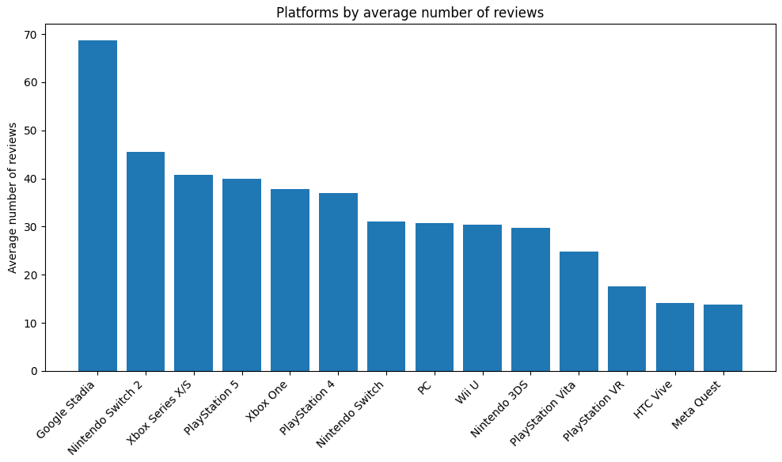
The few games released for Stadia and the Switch 2 drew an inordinate amount of reviews. Critics didn’t care to review games released for HTC Vive, Meta Quest, Playstation VR, and Playstation Vita.

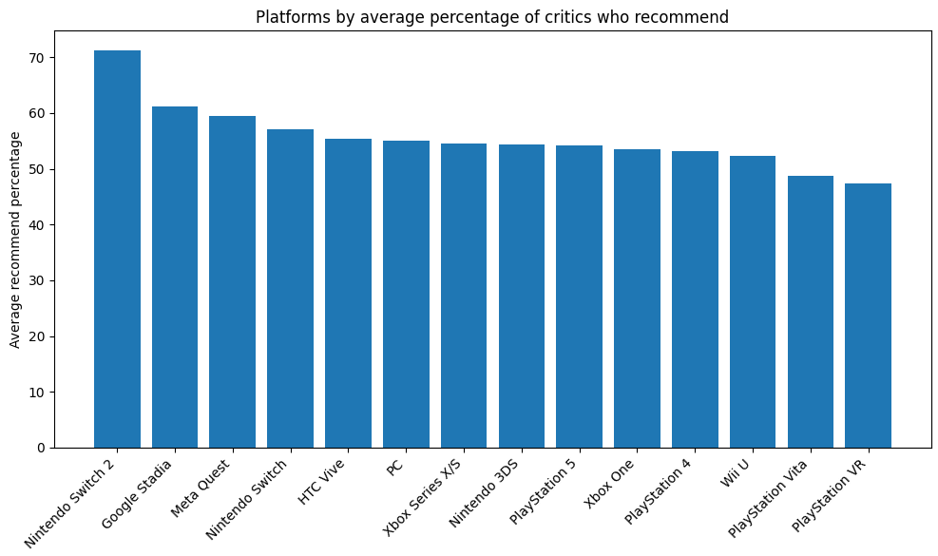
Critics were more likely to recommend the few games released for the Switch 2, Stadia, and Meta Quest. They didn’t like the games released for the Vita or Playstation VR so much.

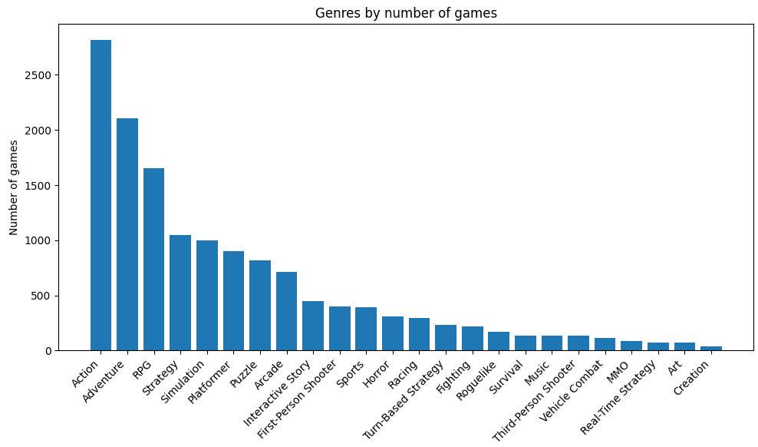
Games that fit into the action, adventure, or action-adventure genres had the most releases. Very few art or creation games were in the dataset.

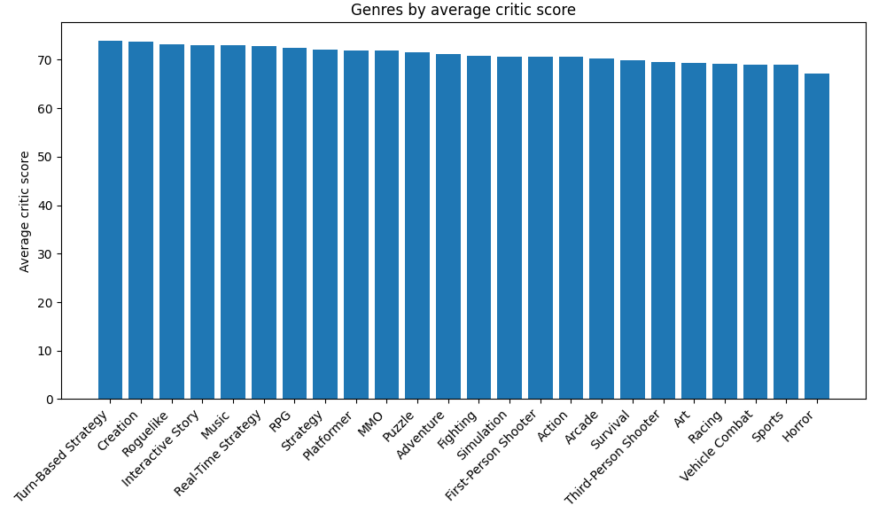
Turn-based strategy is, apparently, a critically acclaimed genre. Horror is not. Creation is a genre that has very few releases, but those releases tend to be beloved by critics.

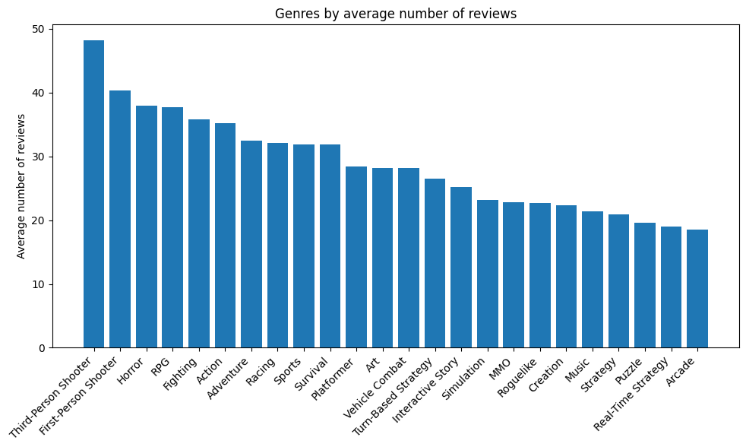
Action and adventure may be the genres with the most releases, but shooters tend to get the most attention from critics.

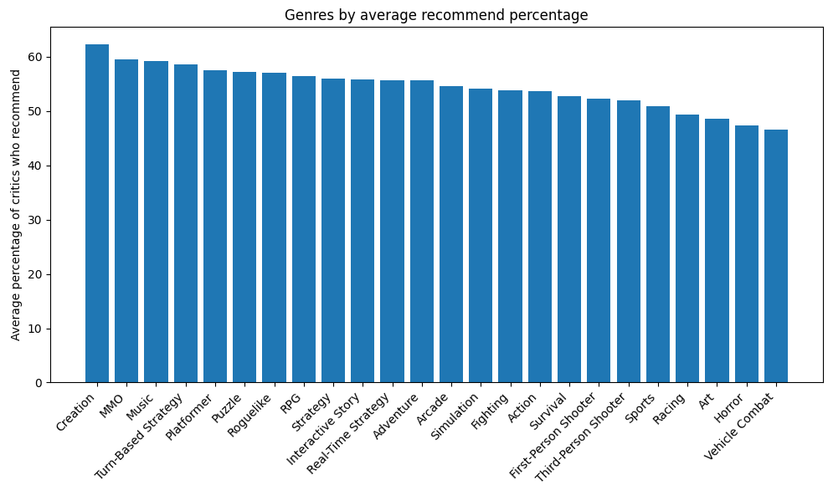
Critics tend not to recommend art, horror, or vehicle combat games. They do recommend games in the creation, MMO, and music genres.
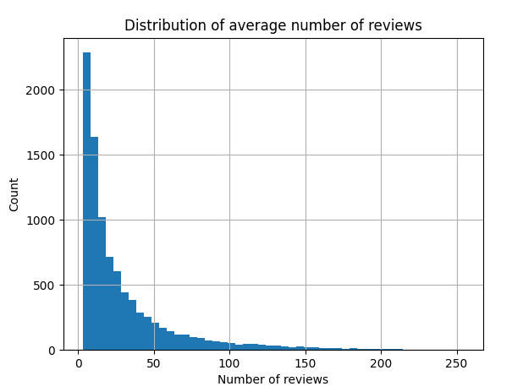
Each game in the dataset has between 3 and 255 reviews. The mean is 30. The median is 17.
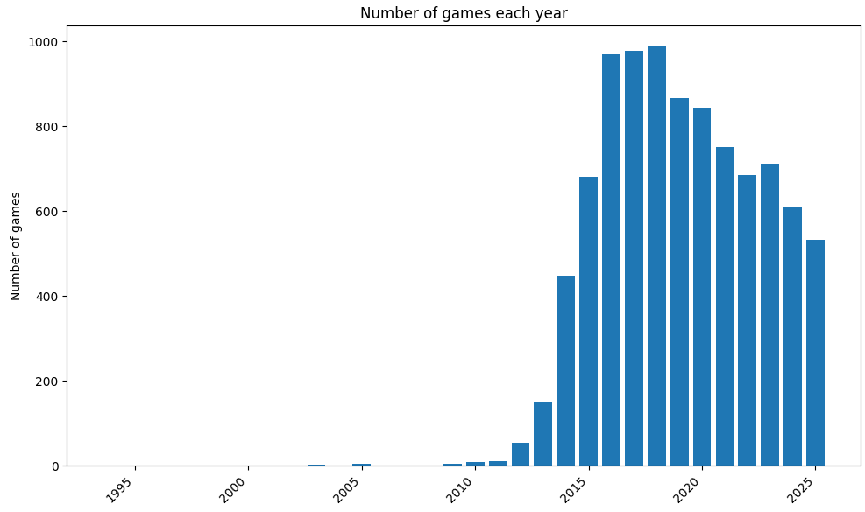
Unlike Metacritic, most of OpenCritic’s games were released in the last decade.

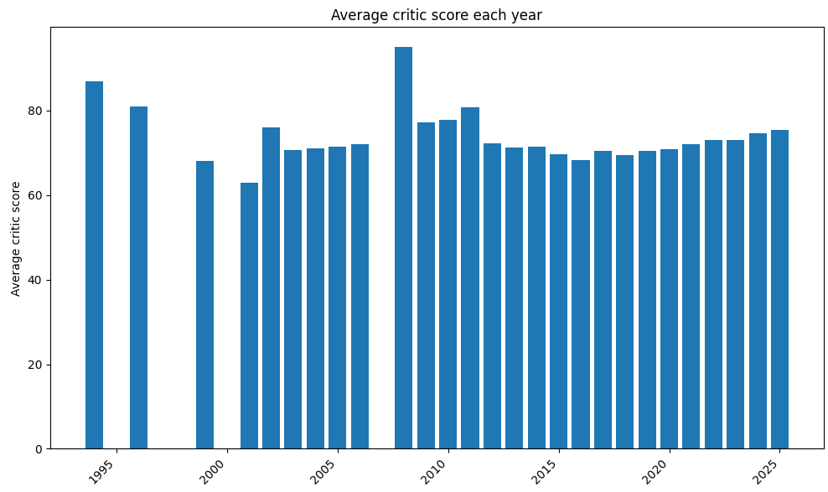
The small number of games in the dataset from before 2014 means that there are a lot of outliers on the left side of this graph. Average critic scores have been increasing since 2018.

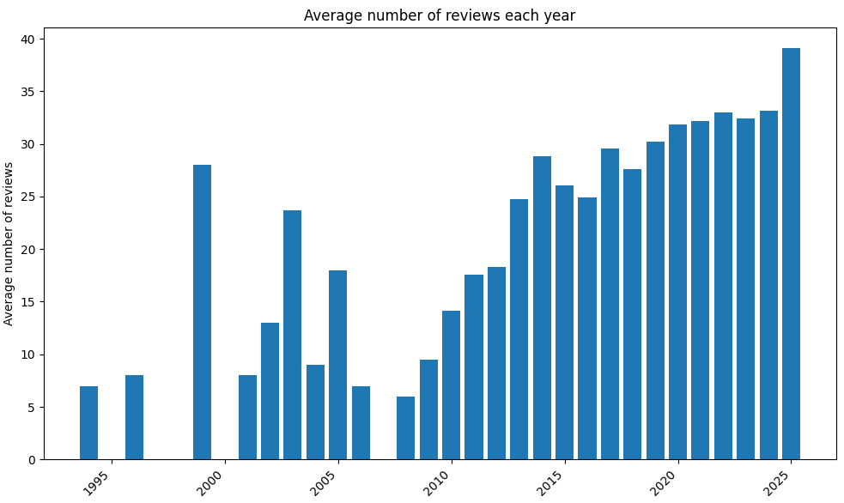
The average number of reviews that each game gets is increasing.
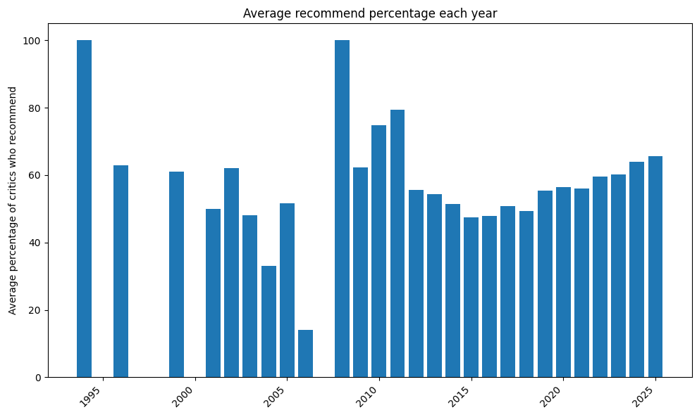
This graph really shows off how bad the data for pre-2015 releases is.
‘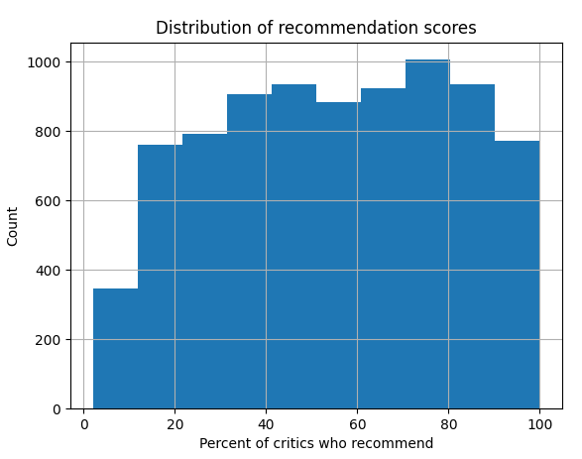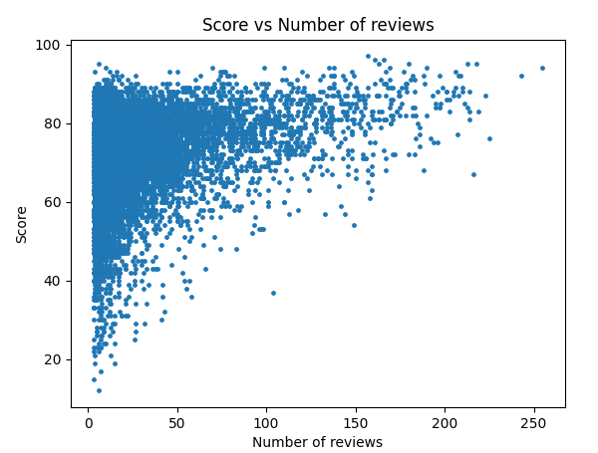
Poorly-reviewed games are usually not widely-reviewed games.

Modeling
This is where I ran out of time. I ended up only implementing a few linear regression models, including a multiple linear regression model. The goal was to determine which factors most strongly predict a game’s top critic average on OpenCritic.
First, I used the number of reviews a game received as an input feature. This explained 8% of the rating variance. Next, I used the critics recommend percentage, which explained 74%. Release year explained 1% of rating variance.
Using all three of these as input features in a multiple linear regression model explained 75% of rating variance. Obviously, almost all of that came from the critic recommend percentage influence, but the other 2 features bumped the value of R-squared up a tiny bit.

Results
Some observations: critical consensus is highly predictive. A game’s “critics recommend” percentage alone explains much of the variance in its top critics average score. Popularity does not indicate quality: the number of reviews received by a game explains only 8% of its score variance. There are distinct review patterns among platforms: Nintendo consoles, Stadia, and Meta Quest receive above-average scores. PlayStation VR, Vita, and Wii U receive below-average scores. Genre matters – some score higher or lower than others – but the most popular genres don’t lead in average scores.
The primary limitation of this study was time constraints. The modeling section of the program, as well as this essay, suffered the most. Different models could have produced interesting results, including using different input and output features. I would’ve liked to have created a model that attempted to predict genre, platform, or creator.

Conclusions
Games on newer or niche platforms receive more attention and often higher scores, suggesting critics may approach these platforms with different expectations. Certain genres consistently outperform others in critical reception, regardless of other factors. Since 2018, both review counts and average scores have increased, suggesting changing critical standards or an increase in average quality.
At the very least, this project demonstrates that web scraping, cleaning, visualizing, and modeling can extract meaningful insights from large datasets.

